I am the True Vine
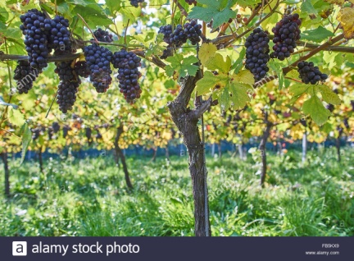
Jesus said, “I am the True Vine, and my Father is the gardener. ² He cuts off every branch of mine that doesn’t produce fruit, and he prunes the branches that do bear fruit so they will produce even more. ³ You have already been pruned and purified by the message I have given you. ⁴ Remain in me, and I will remain in you. For a branch cannot produce fruit if it is severed from the vine, and you cannot be fruitful unless you remain in me. ⁵ “Yes, I am the vine; you are the branches. Those who remain in me, and I in them, will produce much fruit. For apart from me you can do nothing. ⁶ Anyone who does not remain in me is thrown away like a useless branch and withers. Such branches are gathered into a pile to be burned. ⁷ But if you remain in me and my words remain in you, you may ask for anything you want, and it will be granted! ⁸ When you produce much fruit, you are my true disciples. This brings great glory to my Father.”
How many times did you read the word “grapevine” or “vine?” How many times did you read “branch” or “branches?” How many times was the word “fruit” or “fruitful” repeated? And lastly how many times did you read the word “remain”? As you can all see, these words appear quite a bit! Let’s dig a little deeper into their meaning in this passage, so we can better understand what Jesus means when he says “I am the True Vine.”
Where Jesus’ lived grapevines were popular much like if you go to some parts of France, Germany, Australia or new Zealand. They grow where it is warm and sunny. When Jesus says he is the True Vine, he is asking us to use our imagination, look at the vine in the picture above, Jesus says he is like the trunk of that tree, and the roots that go deep down into the ground. All of the branches are connected to the grapevine. Grapes don’t grow unless the branch is attached to the grapevine. So Jesus says we are the branches. We can only grow and bear fruit when we are attached to Jesus.
Thought for today
As we are all attached to the Jesus this makes us part his family, his Father (God) is our heavenly Father too, so Jesus is just like a brother to each and everyone of us and he loves us dearly and wants us to enjoy being part of his family.
Our prayer for today
Jesus, thank you that you have made us to be together as part of your family throughout the world and throughout history. Help us to live as one family, loving each other through the good times and the sad times. Amen
Activity
Ball of purple, blue, green or red wool, cereal card, scissors or the box of Christmas bubbles from the loft, ribbon or string – then either a tree or a scarf
Look at the photos and choose – have fun! Don’t forget to take a photo and share with family and friends
