I am the Resurrection and the Life
At Jesus’ resurrection which we celebrate on Easter Sunday, Jesus came back to life. He’d been crucified and put in a tomb, but he came back to life! And when we believe in Jesus, we can have hope of living with him in heaven forever, even though our bodies may die! Today we’ll learn about how Jesus gives us hope. In today’s Bible passage, we’ll meet a man whose body died—but because of Jesus, that wasn’t the end of things! Let’s find out what happened.
There was a man named Lazarus who was very sick. Mary and Martha, the sisters of Lazarus, took care of him but even though they took good care of their brother, he kept getting sicker and sicker. So they sent someone to tell Jesus that his good friend Lazarus was very sick.
Now Jesus loved Lazarus, Martha and Mary. But Jesus didn’t hurry to Lazarus’ house to heal him. Instead, Jesus said that what was happening would show how great God is. So Jesus waited two days to go see Lazarus.
While Mary and Martha were waiting for Jesus to arrive, Lazarus got so sick that he died. But that wasn’t the end!
When Jesus was getting near the town where Mary and Martha lived, Martha ran out to meet him. Martha said, “Lord, if you had been here, my brother would not have died.” Jesus said to her, “Your brother will rise again.” Martha said, “I know he will rise again in the resurrection at the last day.”
And then Jesus said something amazing to Martha. He said to her, ‘I am the resurrection and the life. He who believes in me will live, even though he dies.’ ” Then he asked Martha if she believed him, and Martha said yes.
Martha then said, “I believe that you are the Christ, the Son of God, who was to come into the world.” Martha hurried back to her house and told her sister that Jesus had come. When Mary heard that Jesus was near, she ran out to meet him. She fell at his feet and said, “Lord, if you had been here, my brother would not have died.”
When Jesus saw Mary and the other Jews who had come along with her were crying, he too was very sad and cried too, he did not like to see his friends so upset. He asked, “Where have you laid him?”
“Come and see, Lord,” they replied.
When Jesus got to the place tomb where Lazarus body had been placed he told them to move the stone away from the door of the tomb. “But, Lord,” Martha said, “by this time the tomb might smell bad because he has been dead for four days.”
Jesus said, “Did I not tell you that if you believed, you would see the glory of God?”
So they took away the stone, and Jesus looked up to heaven and prayed. Then he said in a loud voice, “Lazarus, come out!”
Lazarus came out with his hands and feet wrapped in strips of linen and a cloth around his face. Jesus said, “Take off the grave clothes and let him go.”
Thought for today
It can be uncomfortable and awkward talking about death, but it is something that everyone faces in their lives. For some reason people don’t talk about death maybe because it makes them feel sad, maybe some people don’t know what happens after we die and of course we will miss the people we love when they die. You may know someone, a family member, a friend or a pet, who has died and you will know how it made you feel, share those feelings with someone you trust.
As Christians we believe that Jesus is the one who gives us life after we die. He gives us life in heaven. Our earthly bodies will remain in the earth; it is the part of us which makes us believe in Jesus that will live in heaven with him.
Our prayer for today
Jesus, thank you that you gave your life and rose again for everyone, thank you that you give us hope that you will be with us throughout our lives on earth and that one day when are bodies are in the earth the part of us that loves you will be with you in heaven. Thank you for loving us. Amen.
Activity
Today we are making Gardens and you will need:
Seed tray, or household tray or a flat surface, compost or earth, sand or shingle or small stones
small flower pot, or plastic tube or heavy duty cardboard tube, moss, a little clump of daisies or buttercups or dandelions or primulas or violas, two twigs or lollipop sticks, string,
card or a pebble/stone about the circumference of the flower pot

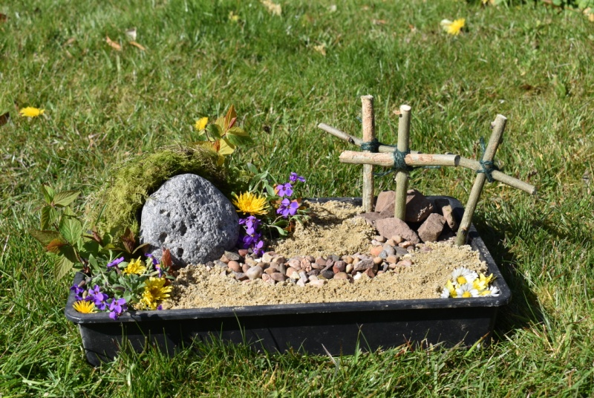

When you have finished making your Garden, take a photo and share it with family and friends

