I am the Way, the Truth and the Life
A poem by Bob Hartman from Telling the Bible – Over 100 stories to read out loud!
I am the Way
I’m going to my Father’, said Jesus to his friends
Said Jesus, ‘I’m going away.
But there are many rooms in his house,
More rooms than you can count,
And I promise to take you there, one day’.

‘But how will we get there?’ asked Jesus’ friend Thomas.
Said Thomas, ‘show us, we pray.
Don’t leave us alone.
We don’t know where you going!
So how can we know the way?’

‘I am the Way, (the Truth and the Life)’, said Jesus to his friends.
Said Jesus, ‘I am the way.
The Father’s Life
And the Father’s Truth
Is all I do and say.’

‘Then show us the Father!’ said Jesus’ friend Philip.
Said Philip, ‘Then all will be well!’
‘If you’ve seen me,’ said Jesus
‘You’ve seen him, too!
We’ve been together for years, cant you tell?’

I’m in the Father,’ said Jesus to his friends.
Said Jesus, ‘He’s in me, too.
The words I say,
In the stories I tell,
In the miracles you’ve seen me do.’

‘You will not be orphans,’ said Jesus to his friends.
Said Jesus, ‘You won’t be alone.
My Father will send you
Another companion
So you will not be on your own.’

‘his Spirit will live within you,’ said Jesus.
Said Jesus, ‘Within you he’ll be.
Then we’ll all be one,
Father, Spirit, Son –
Together for eternity.’

Thought for today

I know that when I am lost, I would rather have someone show me the way instead of just telling me how to get there. Jesus leads us to the Father (God). He doesn’t say that he knows the way, he says he IS the way. To follow him all we need do is love those around us, love ourselves because God has created you beautifully and wonderfully and he loves you and to believe in Jesus, his Father and the Holy Spirit.

Our prayer for today

Jesus, thank you for being the way to the Heavenly Father for your people throughout the world and history. Help us to help others to follow you, loving each other through thick and thin. Amen
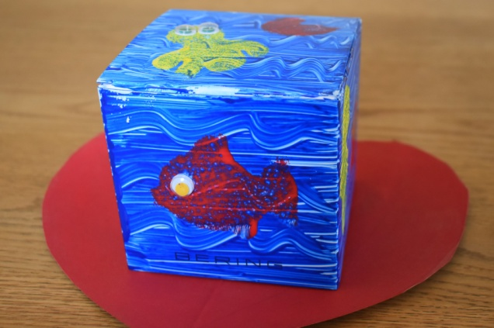
Our final Activity
Empty shoebox or similar box like container with a lid, wrapping paper or poster paint, access to the internet and printer or a good supply of paper, colouring pens, scissors, cut out shapes.
Today you will be making a special box to hold your prayers and hopes for yourself and for those you love. When finished take a photo of the outside and share it with family and friends

May God bless you and those you love with His love and surround you with His peace now and forever. Amen.

