Church of St Mary Magdalene

Annual Report and Financial statements
of the Parochial Church Council
for the year ended 31st December 2022

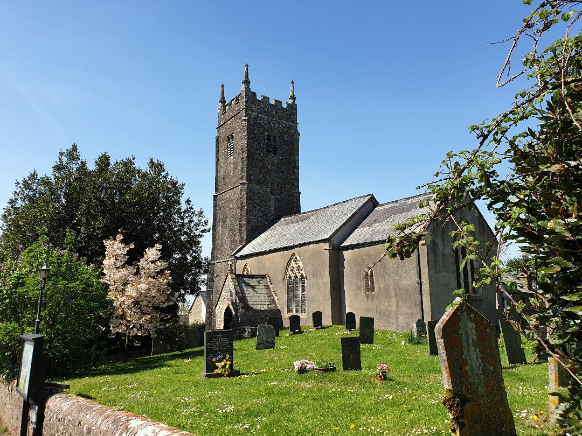

Rector: Reverend Gary Owen
Focal Minister: Tim Overton

Bankers: Barclays Bank, Barnstaple

Independent Examiner:
Robert Hemsworth
Warmington Hill
Alverdiscott Rd
Bideford
EX39 4PN

Website: www.tworiversmissioncommunity.org

The Parochial Church Council is an Excepted Charity
The Parochial Church Council of St Mary Magdalene

Annual report
For the year ended 31st December 2022

Aim and Purposes
St Mary Magdalene Parochial Church Council (PCC) has the responsibility of cooperating with the incumbent, the Rev Gary Owen, in promoting in the ecclesiastical parish, the whole mission of the Church, pastoral, evangelistic, social and ecumenical. The PCC is also specifically responsible for the maintenance of the church building

Objectives and Activities
St Mary Magdalene Church is part of the Two Rivers Mission Community, an area of 56 square miles between Barnstaple, Bideford, Torrington and Atherington. The Mission Community aims to build a Christian community in each village, which will worship, pray, grow and reach out with the Gospel.
We recognise that we exist to serve and bless the whole parish and to grow and make visible the kingdom of God. Our building and churchyard are valuable community resources and we value the support of parishioners in maintaining and utilising these for the benefit of the community.

Achievement and Performance
There were four entered on the electoral roll at the 2022 AGM, two who live in the parish. None were added and none removed. The average Sunday attendance was six. The number of participants was 3.2.
The main festivals were celebrated including Easter, Harvest Festival and Christmas. Other activities included celebrating the Platinum Jubilee and bells.
In December 2022 Rev Gary held a “getting to know you” and church tidy up coffee morning in church. Plans began to be made for holding more services in church.
For information about achievements and performance as part of the Two Rivers Mission Community see appendix 1.

The church is now opened to the public on a daily basis between the hours of 10 am to 4 pm. A prayer box has been installed and there is a permanent display of flowers on the alter.

Deanery Synod
Rev Tracey Doyle is the rural dean and co-chair of the deanery synod. Mr Derek Birch is the other co-chair. The synod met three times during the year and heard presentations about parish nursing (February) and rural mission (September). A meeting June facilitate discussion about the joys and challenges of ministering as the Church of England.
The possibility of holding a festival of faith was discussed but insufficient support meant it could not proceed.
The deanery chapter of clergy normally meets every month on Zoom for mutual support and sharing of information.

Church Fabric
The fabric of the church has been maintained with minor repairs carried out as required. Church cleaning events have taken place. The outside shed roof was damaged by spring storms and remains intact in the church yard. The church yard has been maintained with regular grass cutting throughout the year. A small wild flower section is flourishing.
The three bells remain at Taylors Bell Foundry, Loughborough where repairs and restoration are taking place. The bells will be returned and rehung in October 2023. Much of the old wood from the bell frames (most of it dating from medieval times) has been stored at the rear of the church. It has yet to be decided what to do with the wood.
The PCC would like to thank all individuals who have helped with maintenance and cleaning of the church and who have contributed to the bell appeal. We are grateful to Alverdiscott and Huntshaw Parish Council for their contribution to the support of the maintenance of the churchyard.

Financial Review
There is currently £3,537.61 in the PCC bank account. Income from the investments have held up. Common Fund payments were maintained. A collaboration with the Parish Hall committee has continued with joint events taking place with 50% of proceeds going to the Friends of the church. Several fundraising events for the bell appeal has taken place.

The PCC would like to thank everyone who contributed to church finances. Regular donations by the Parish Giving Scheme or standing order are particularly appreciated as they provide a regular income regardless of whether the building is open for worship and enable the PCC to manage a budget effectively.

Safeguarding
The PCC has complied with the duty under section 5 of the Safeguarding and Clergy Discipline Measure 2016 (duty to have regard to the House of Bishops’ guidance on safeguarding children and vulnerable adults).
The safeguarding officer is Mr Derek Birch.

Structure, Governance and Management
The method of appointment of PCC members is set out in the Church Representation Rules. The council comprises the incumbent, licensed clergy, churchwardens, readers appointed by the Annual Parochial Church Meeting, those elected to the deanery synod and other members elected at the Annual Parochial Church Meeting by those on the electoral roll.
The PCC members are responsible for making decisions on all matters of general concern and importance to the parish and for all financial matters.
A new legally constituted Joint Council came into existence on 1st January 2022. The focal minister of each church and up to two elected representatives from each PCC represent each PCC on the council. The PCC has delegated various responsibilities to the Joint Council in accordance with the Joint Council Scheme.

Administrative information
The church is situated in the village of Huntshaw. The parish is in the deanery of Torrington, archdeaconry of Barnstaple and Diocese of Exeter. The correspondence address is The Rectory, High Bickington, Umberleigh, EX37 9AY.

The PCC is a body corporate (PCC Powers Measure 1956 and the Church Representation Rules 2020) and a charity excepted from registration with the Charity Commission.

PCC members who have served since 1st January 2021 until the date this report was approved were:
Ex officio
The incumbent | Rev Gary Owen | Chair
Licensed clergy | Rev Tracey Doyle
Curate (and parish nurse) | Rev Julia Halpin
Focal minister | Tim Overton
Deanery synod rep | Vacant
Church wardens | Vacant

Elected
 | Audrey Alimo | Secretary
 | Lesley Wall | Treasurer
 | Jenny Staines

Approved by the PCC on date and signed on its behalf by:

………………………………….. …………………………………..
Rev Gary Owen [Insert name, ]Vice chair

Church of St Mary Magdalene Accounts
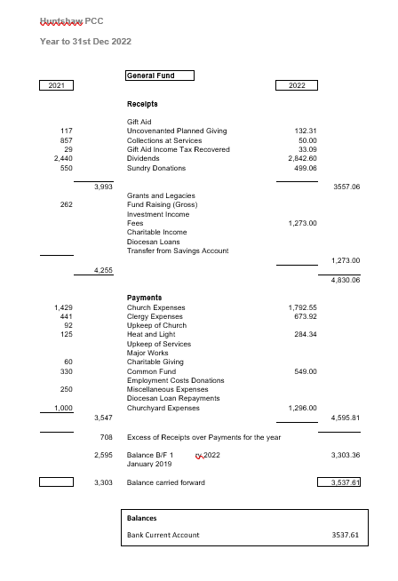
Huntshaw Parish St Mary Magdalene Church

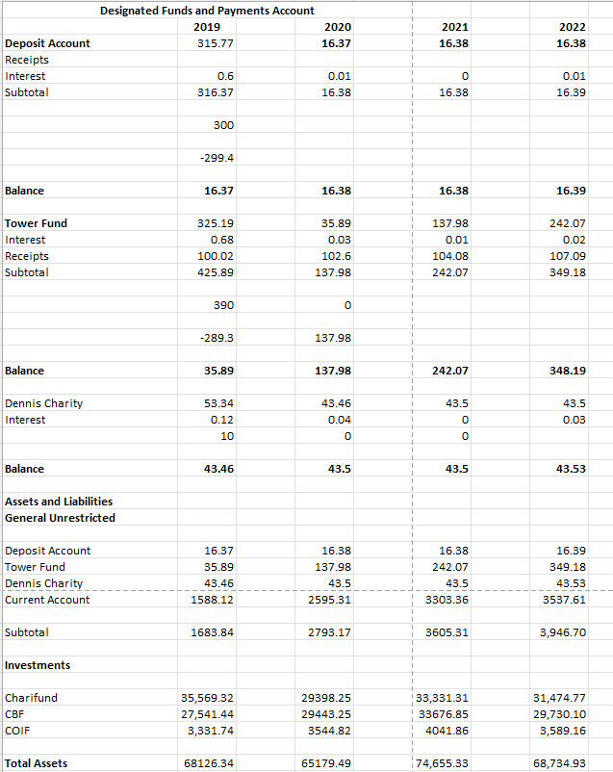
EDBF £5,000 loan

Appendix 1
Two Rivers Mission Community Annual Report for the year
ended 31st December 2022

2022 has been a year of consolidation and growth. On Sunday 9th January Bishop Jackie led a mission community service in Tawstock to launch our mission action plan, and commission our new joint council and focal ministers. As the year has progressed, we’ve worked hard on building the mission and ministry of the church in each parish, as well as strengthening our collective work as a mission community. The removal of the last covid restrictions and increased confidence of people to mix has helped tremendously.

Sundays are the main focus of our lives together as Christians. Seven churches have met weekly and two others twice per month. Sunday services give us chance to worship together, pray, grow as disciples, and plan outreach. Importantly they are also a time for fellowship as Christians and mutual support. We normally follow the lectionary readings from Advent to Trinity Sunday, to focus on life of Jesus and then take a more flexible approach for the remainder of the year. At the beginning of the year, we preached a series looking at our Mission Community values of love, faith, Word and Spirit, generosity and joy. During the season of Trinity, we preached sermon series on the biblical books of Colossians and Esther, and a short series on Psalms quoted by Jesus. Seven of our churches now hold a monthly family service, including a new café church service in Yarnscombe which makes use of the warmth and facilities of the village hall. Festivals and ‘special’ services are used as an opportunity to invite people to church and agricultural festivals are important in many parishes.

Opportunities for adults to grow as disciples have been provided by homegroups, with 6 running during the year. An Autumn weekend away at Lee Abbey proved inspiring for the 15 adults and 2 children who attended. In the Autumn two church members commenced the Diocesan Foundations in Christian ministry course.

Our commitment to helping children respond to the gospel and grow as disciples as part of the church has been worked out in a number of ways. The out of school club in High Bickington and youth group in Newton Tracey continued and a new youth group and kids club launched in Beaford in May and September respectively. We still have no provision for pre-school children, but our parish nurse is a regular visitor to most local toddler groups and a Christmas visit to church was enjoyed by the toddler group in Beaford and at Christmas and Easter to St Giles. There is scope for more work with this important group, especially as we baptise 10 – 15 babies or young children each year.

We are blessed with a good working relationship with our four local primary schools; with collective worship conducted weekly in High Bickington and approximately twice per half term in the others. Open the Book collective worship runs in High Bickington and has recently restarted in HNTPS. All the schools make use of the clergy and churches for RE lessons when appropriate topics allow.

Evangelism, sharing the good news of Jesus and inviting people to enter a relationship with God through him, remains a priority for us. We encourage church members to share the Gospel with friends and neighbours and to invite them to church services and events where they can learn more and experience Christian community. We ran two Alpha courses in the Autumn, one in Beaford and one in Tawstock, with around a dozen guests in total. We also ran a youth Alpha course during the Autumn in Beaford village hall.

Our churches have continued to help members care for each other, largely through informal relationships and through the pastoral care offered by ministers. Care for the wider community has been expressed through coffee mornings and other opportunities to gather, and increasingly as the cost of living has risen, the provision of free meals, food banks and warm spaces. St Giles church are operating a much-valued pastoral care team, which offers friendship to those who need it.

Julia, our parish nurse, and now deacon, provides more specialist pastoral care, visiting the sick and housebound, accompanying parishioners to medical appointments and offering support on medical issues. She visits toddler groups and offers baby weighing and general advice. Julia has begun to officiate at funerals for those she has been supporting through end of life care.

During the year we conducted 14 baptism, 15 weddings and 34 funerals/burial of ashes across the mission community. 22 weddings are booked so far for 2023. These pastoral offices are a wonderful opportunity to share God’s love and the good news of Jesus with people at both the high and low points of life.

During the year Rob Pearce was appointed as focal minister for Beaford and joined the Leadership team. As the church in Beaford has grown and church members stepped further into ministry, Rev Gary has been able to step back a little. He has begun to work with the parish of Huntshaw to see if progress can be made in re-establishing a regular worshipping community there.

We seek to play an active part in the life of the Diocese and wider church. Rev Tracey has served throughout the year as rural dean. She and Derek Birch have served as co-chairs of deanery synod and other church members have served as deanery synod officers. We have provided a placement for a licenced lay minister trainee, who in turn blessed us with her enthusiasm and ideas.

We are delighted that a new curate has been appointed to join us in July 2023. We failed to appoint a new team vicar during 2022 and this has put a certain amount of pressure on the clergy. We continue to pray that someone will join us in 2023.

All our churches have maintained their common fund payments throughout the year – a wonderful achievement. Our common fund request will increase in 2023 due to our increasing participant numbers. This is only fair, not least because we remain heavily subsidised by the Diocese. Church members giving regularly and generously (ideally by direct debit or the parish giving scheme) helps ensure that we can meet our bills. Churches have worked hard to maintain their buildings and to improve them to better serve the mission of the church and local community.

As a mission community we are blessed with many people who play their part in making the mission and ministry of our parishes possible. We thank our focal ministers, wardens, PCC members and all who contribute their gifts of time, talent and money to our churches. Retired clergy have been invaluable in ensuring that priestly ministry has been available in each parish. Janette has provided administrative support. We are what we are because of you all.

We do not know what will occur during the year ahead, but we look forward to joining in with God as he fulfils his promise to build his church and kingdom. “Now to Him who is able to do exceedingly abundantly above all that we ask or think, according to the power that works in us, to Him be glory in the church by Christ Jesus to all generations, forever and ever. Amen.”

Rev Gary (Rector)

Appendix 2
Mission Action Plan
