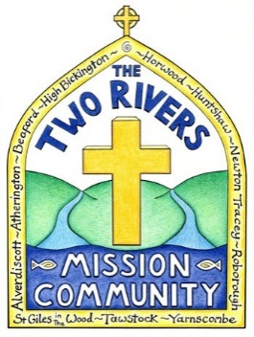

The Two Rivers Mission Community
Called by God to build a Christian community in each village,
which will worship, pray, grow and reach out with the Gospel
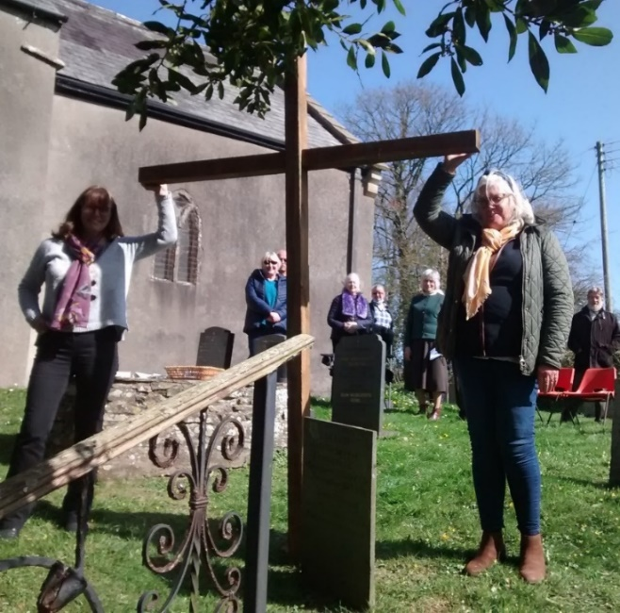

Parish Profile for a

Half Time Team VicaR
www.tworiversmissioncommunity.org
For further information contact Rev Gary Owen
01769560792 or revgaryowen@gmail.com

Contents

- Contents and Dates
3 A message from Verena Breed, Archdeacon of
Barnstaple
5 Team vicar role description
7 Team vicar person specification
8 What we offer
9 The team vicar’s house
10 The Mission Community
13 Our Mission Action Plan
14 Our parishes
16 The Parish of Tawstock
17 The Leadership team
19 The surrounding area
21 Mission Community statistics

Dates
Closing date: tbc
Interviews: tbc
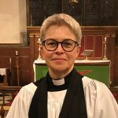
A message from Verena Breed, Archdeacon of Barnstaple

This post presents a fantastic opportunity for an imaginative and creative priest to work with a committed group of parishes seeking to deepen their working together as a Mission Community, to bring together churches and communities, and to grow in faith and discipleship. We would hope that the right candidate will bring experience, energy and innovation to this role of Team Vicar, as part of a committed ministry team, lay and ordained.
You will be joining a dynamic team and a Mission Community which is committed to finding new and exciting ways to engage with rural ministry, is open to creative new forms of ministry and mission and is at the forefront developing focal ministry.

Our Diocesan Vision
We seek to be people who together are:

Growing in Prayer
Prayer is conversation with God and is part of a healthy Christian life. Prayer is a life-giving activity that opens up deep places within us to God’s transforming grace. It is essential if we are to become the people and the Church God calls us to be.

Making new disciples
As the Christian story is less and less known, we must find new ways of telling the story, of explaining the faith and giving a reason for the hope that is in us. With Jesus Christ as our companion and guide, we can travel through life differently.

Serving the people of Devon with joy
As followers of Jesus Christ, we want to make a difference in the world and make God’s love and justice known. In our church life, we seek to be local, participatory, and outward-looking.

Further information regarding our Diocesan Vision can be found in our Next Steps document at
www.exeter.anglican.org/who-we-are/vision-strategy

Living in Mission Communities
Our strategy centres on Mission Communities - parishes working together to share the Gospel of Jesus Christ more effectively in Devon. The phrase Mission Communities sums up what we need to be as a Church in the 21st century: mission-orientated, community-focused, and locally-rooted.

Mission Communities help us to work together and support one another better. They enable us to be more flexible in our mission and more responsive to the different contexts and cultures of Devon.

A Mission Community aims to express the fullness of the life of the Church locally. This will include:
· regular prayer and worship
· pastoral care
· evangelism and mission, often in collaboration with ecumenical partners
· opportunities for learning, teaching, nurture and growth for disciples of all ages
· youth and children’s work and worship
· equipping members for ministry in the community and the local Church
· connecting with the local community, especially in service to the poor
· good administration and stewardship of time, resources and buildings

If our Mission Communities are to flourish, they need to be more than just a structure. They need to live and embody the life of Jesus Christ and to share that life with others. Jesus came so that we can have life in all its fullness. That is our vision and our hope for the Church in Devon.

In this Profile, you will find something of the vision and challenges of this Mission Community. I commend it to your study and prayer as you seek to discern your next step in ministry.

Deanery & Diocese

The Mission Community falls within the Archdeaconry of Barnstaple, and so under the care of the Bishop of Crediton. The Two Rivers MC is in the Torrington Deanery whose Rural Dean is The Rev’d Tracey Doyle. Tracey is a member of the Two Rivers MC and Focal Minister for High Bickington and Atherington.

In the Diocese of Exeter, we are working together to live out our three diocesan priorities - to grow in prayer, to make new disciples and to serve the people of Devon with joy. We aim to be a diverse and truly representative diocese, and particularly welcome applications from women and those from black and minority ethnic groups. Not only is Devon a beautiful place to call home, but we believe the Diocese of Exeter is a great community of which to be a part.

You are warmly invited to contact me directly if you would like a confidential conversation about the post.

We look forward to welcoming you to the Diocese.

The Venerable Verena Breed
Archdeacon of Barnstaple

Role Description

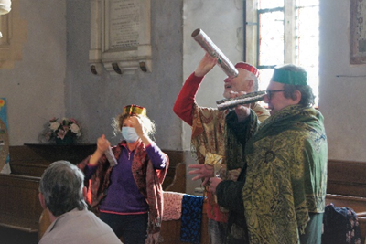
Our new team vicar will be a full member of the mission community joint council and leadership team.

Initially he/she will take responsibility, for the parish of St Peter’s, Tawstock. The parish is strategically very important to the mission community and we are committed to making it possible for our new vicar to spend the majority of their time building up the church rather than chasing around the mission community and doing admin.
Are you the team vicar we are looking for?

Tawstock parish is large in size, taking in the hamlets of Harracott, Lake and Eastacombe as well as the ‘village’ of Tawstock and many outlying farms. It is the second most populace parish in the mission community (700 people). The participant number is 22, the fourth largest in the deanery and Sunday attendance is around 15, rising to 20 adults plus 10 children for the monthly family service. The church building is popular for weddings, being beautiful itself and situated next to a popular reception venue. We work hard to build relationships with wedding couples and many return for christenings and festivals. Some are now attending family services. There is a church school.

Our new team vicar will:

- Chair the local leadership team/PCC, helping to formulate a vision for growing the church in line with the mission community vision to “build a Christian community in each parish which will worship, pray, grow and reach out with the gospel.”

- Facilitate church members to grow in ministry in order to implement the discerned vision.

- Work with those coming to the church for life events and seek to help them engage with Jesus and his church.

- Build on the good relationship with the church school, to support school life and build bridges with the church.

- Focus on helping all ages hear the gospel, become Christians, grow as disciples and make an impact in their daily lives for Jesus. This will include children, young people and families, with whom we have good contacts and opportunities.

We appreciate that our new vicar will be half time. We are not looking for someone to do everything. Indeed, this would be counterproductive. Rather we are looking for someone to make the most of the opportunities distinctive to being the parish priest and to release others into the ministries God has called and equipped them to.

Our hope is that as the church grows it will be possible for the team vicar and others from Tawstock to begin to offer more support to other churches in the team to enable them to emulate what will be the success of Tawstock.
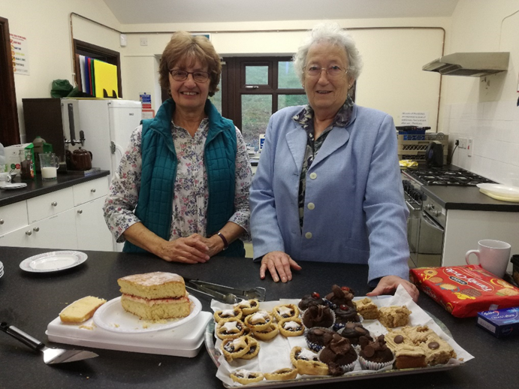
There are many fantastic local walks... great for working off that extra piece of cake

Person specification

- A lively, infectious Christian faith, full of faith, hope and love.

- A love for the local church; seeing it as a Christian community called by Jesus to love and witness to the wider community; a passion to see churches grow and flourish; gaining more satisfaction from seeing others succeed in ministry than doing it yourself.

- Experience of helping people find faith in Jesus and growing disciples.

- A track record of using Life Events to grow the church.

- Experience of ministry with children and young people, growing their faith and spiritual life.

- An understanding of rural ministry, or a willingness to learn quickly.

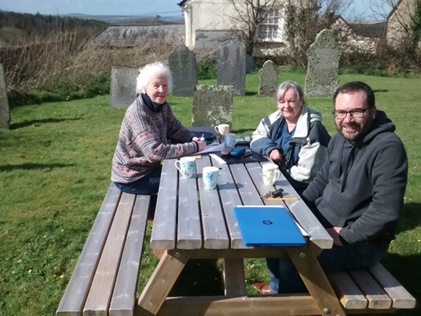

A meeting of the Huntshaw PCC... it was warmer in the sun than inside the church!

What we offer

- A mission community at the cutting edge of developing oversight/focal ministry; being part of an exciting adventure to find new and innovative ways of valuing and growing the rural church.

- A leadership team made up of clergy, licenced ministers and others, which prays and plans together; a team that’s excited about God and his plans for the mission community.

- The chance to focus on one church, parish and school, with lots of potential, but with the advantage of support (holidays and time off can be easily covered).

- A comfortable four-bedroom vicarage.

- Full expenses and allowances.

- Very little admin and the chance to spend your time on growing the kingdom of God.

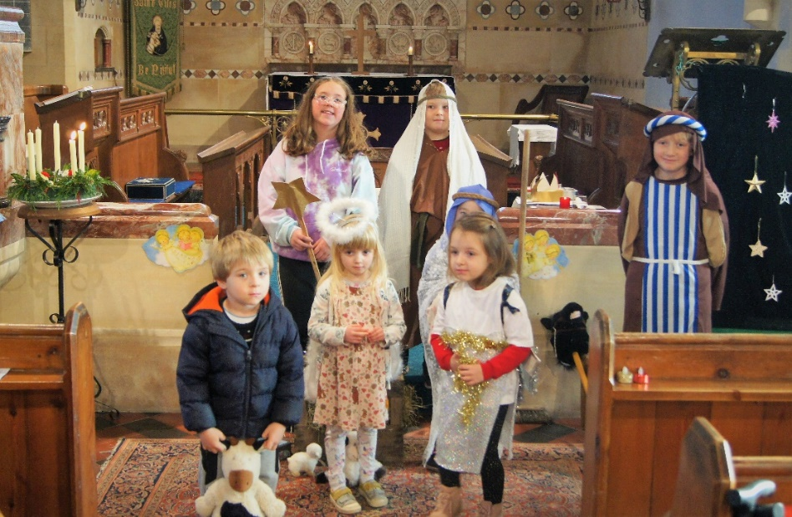
Festivals are well supported and much appreciated by the community
The Team Vicar’s House

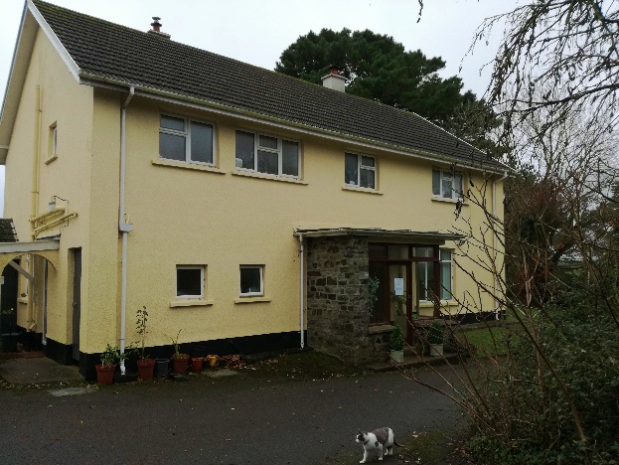
The team vicar will live in Newton Tracey, which borders the parish of Tawstock. Newton Tracey is just 3 miles from Barnstaple and a bus service connects the village to the town. The village pub is a few minutes’ walk away and the cricket club round the corner.
The house itself benefits from a good sized study, downstairs toilet, living room, dining room, kitchen and utility room. There are 5 bedrooms upstairs. It is in a good state of repair and budgeted funds are available for decorating on occupation. There is a large garden, predominantly laid to lawn but with scope for development should the occupant have green fingers.

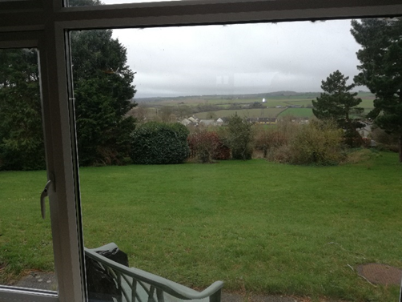
The Two Rivers Mission Community
The view from the lounge window

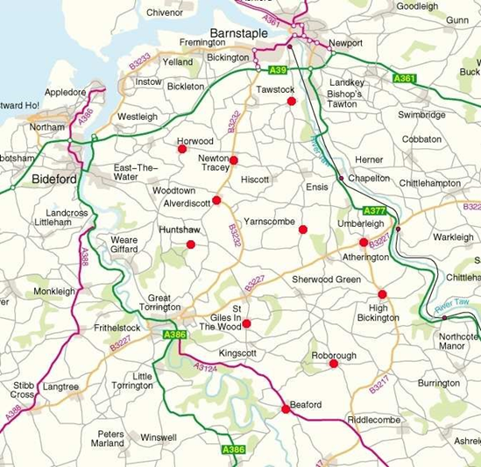

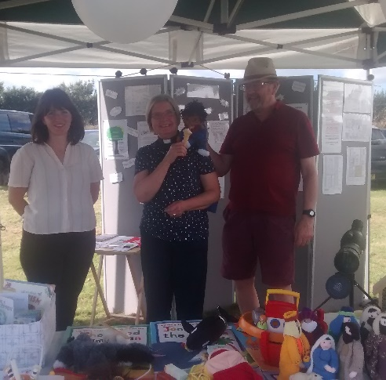
The mission community is made up of 10 parish churches and a chapel of ease. We’ve been together now for over 20 years and are happy and confident as a group. An informal mission council has now become a Joint Council and whilst parishes retain responsibility for their own building, finances and local mission the joint council enables us to take counsel and plan together. It also enables us to reduce admin and free church members for ministry.

We believe passionately that we are called to build Christian communities in each parish which will worship, pray, grow and reach out with the Gospel. For the last two years we’ve been working towards holding a “service” in each church each week.
Summer Fetes are a great place to share what's going on in church... and impress people with our hats!
Pastoral and missional work grows out of this weekly meeting. We’ve adopted an oversight/focal ministry model of resourcing the churches, with each parish having its own member of the leadership team acting as a focal minister and local team leader. We also enjoy the support of 4 PTO priests and a PTO reader. We are delighted that, despite covid, we have seen growth in several of the churches, and others have held their own.

Our emphasis is on helping each parish to thrive. This means providing some ministry at mission community level which parishes can access. We provide most training at mission community level, although we also offer more personal or targeted training locally. Some activities which take place across the whole mission community are marriage prep, confirmation prep and special events such as involvement in Thy Kingdom Come.

We are working to provide something for every age group in the mission community to help people hear the gospel and grow as a follower of Jesus.

Evangelistic efforts are focused on Alpha. So far, the success of the course has largely been in helping Christians become more confident in explaining their faith, although there have been a small number of people come to faith. We are presenting nine candidates (eight adults and one teenager) for confirmation in May 2022.

Six homegroups meet fortnightly to help adults engage with the scriptures, pray and enjoy fellowship mid-week.

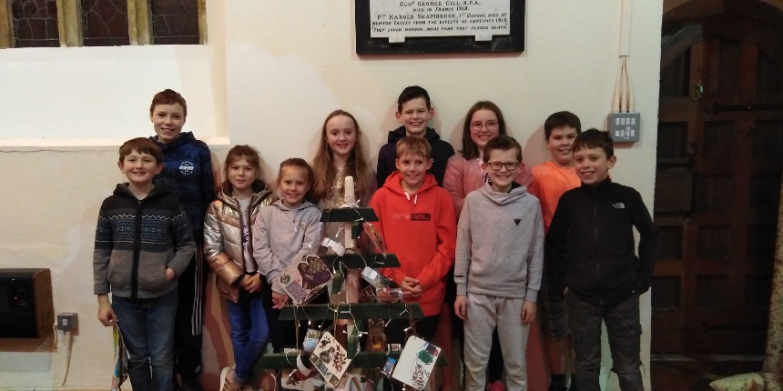
We are working on our provision for children and teenagers and have now built up to an out of school club (school years 1-6) and two youth groups (aged 8-12 and 10-14). We trust that more provision will be in place soon. Relationships with schools are good and each of the four schools in the Mission Community welcome church assemblies.
The youth group in Newton Tracey

A parish nurse deacon leads the pastoral work of the parish. She is involved in local toddler groups and offers support to new mothers.
There is an active social/fundraising life to most of the churches. Coffee mornings are frequent and well attended.

In terms of theology, we are typical village churches, seeking to provide a Christian home for people of all church traditions and none! The leadership team hold a variety of theological convictions, but we are united in our love for Jesus and our common aim of making disciples and supporting them to live for Jesus. The rector (training incumbent) is evangelical/charismatic, and a vicar would need to be willing to work with someone of these convictions.
There are approximately 20 baptisms, 15 weddings and 20 funerals each year.
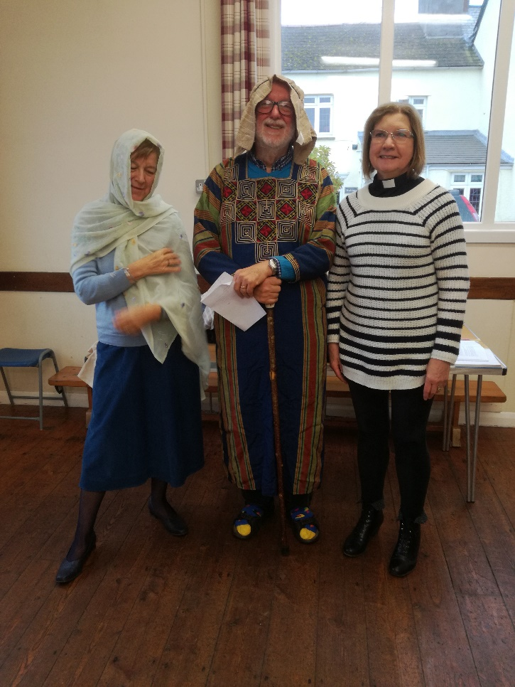
The Open the Book team take Christian bible stories into the schools in High Bickington and Lovacott

Our Mission Action Plan

agreed by the Mission Council and PCCs in June 2021
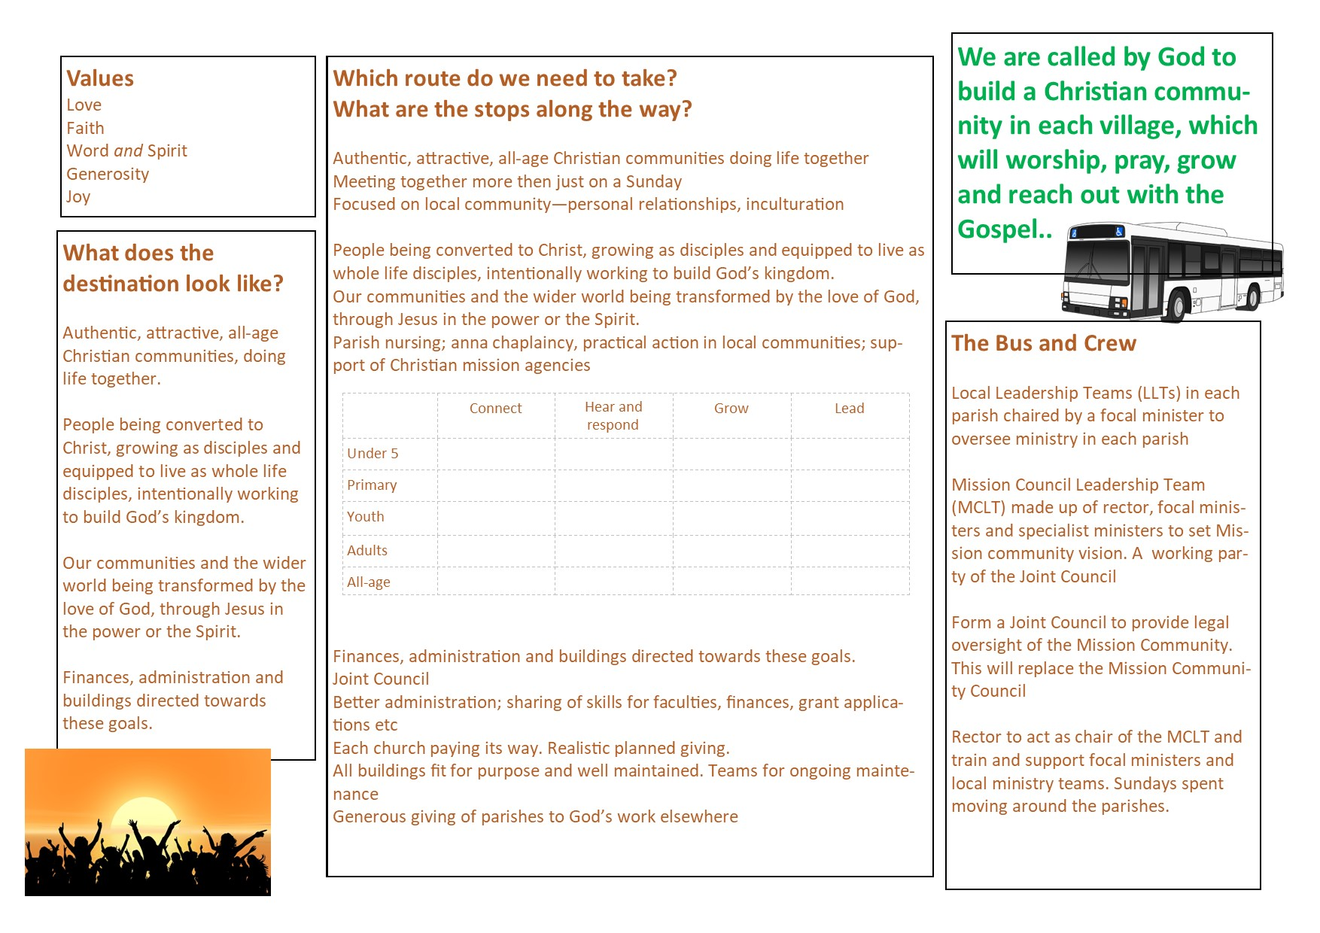

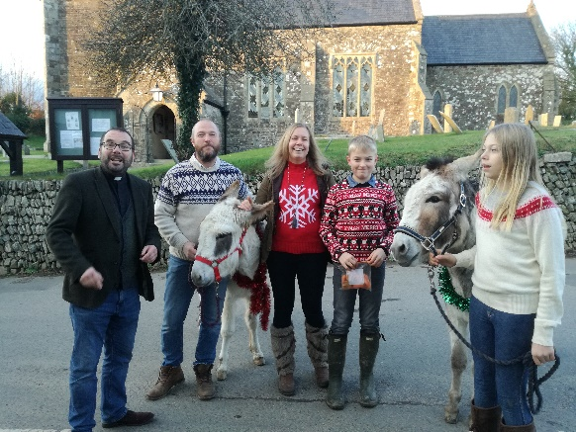
Our parishes
St Giles in the Wood is one of our largest buildings and is home to a congregation that has grown from 6 to 20 in the last two years. Coffee Cake and Company, pictured here, is a great meeting place for church and community. A homegroup meets bi-weekly and a pastoral visiting team has just been launched. Sunday worship is informal in style and led by a variety of congregation members.
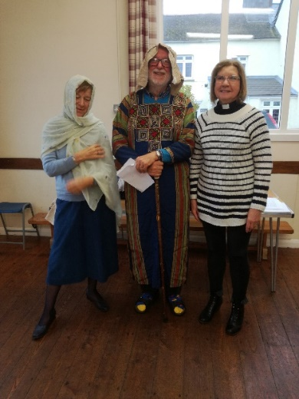
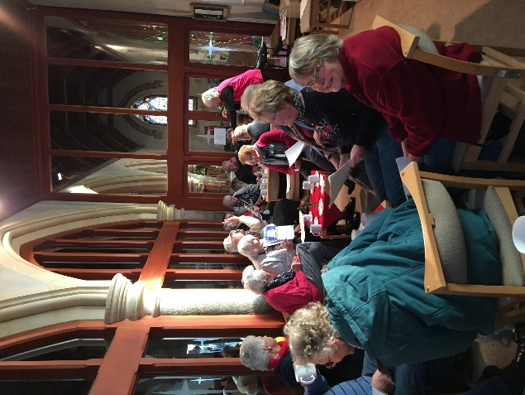
Roborough is a small farming community. Animals and farm machinery are frequent visitors to church. Activity mornings on special occasions prove popular with families and the monthly biscuit club ensures no one in the parish lacks sugar.
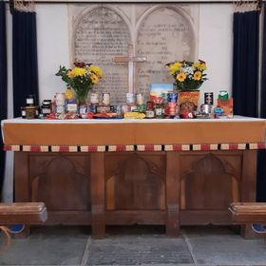
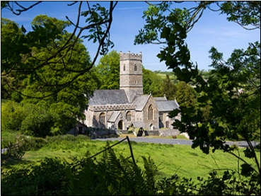
Huntshaw is a tiny rural parish. We’re looking at creative uses of the building, including ‘champing’ – church camping!

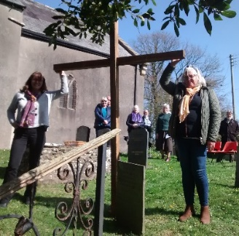
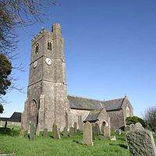
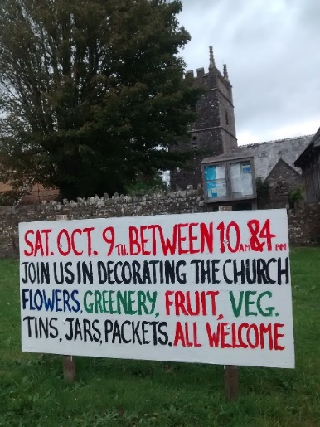
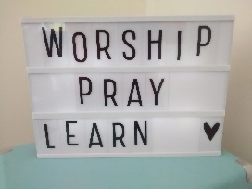
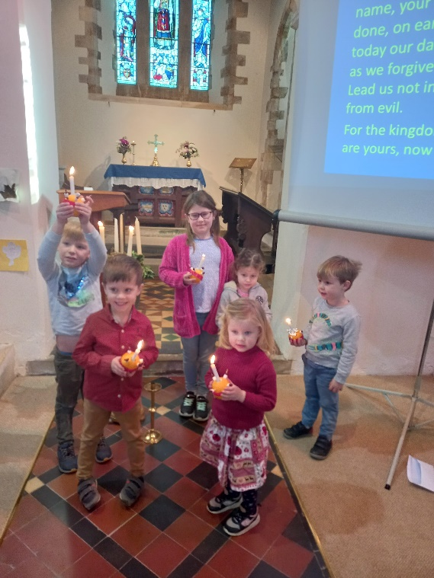
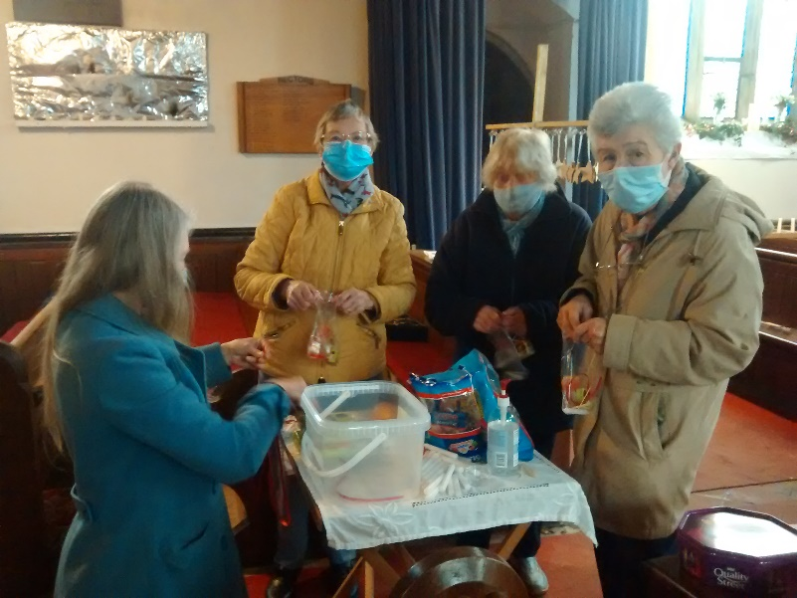
The Parish of Tawstock
Yarnscombe is a tiny community in the centre of the mission community. A homegroup meets bi-monthly.
Tawstock is our most popular church for life events, with an average of 10 weddings and five baptisms per year. A growing family service is developing links with local families, as well as those who have enjoyed marrying and having children baptised in the church. There are good links with the village church school.
High Bickington is the largest parish. Church and school work closely together and a monthly out of school club attracts around half the school pupils. A new monthly muddy church in the local woods is attracting young families not normally in church. There’s a bi-monthly homegroup, monthly coffee morning and seasonal choir. A recently added toilet and tea station make the church building more welcoming.
Atherington works with High Bickington, with which it shares a school. It’s the only church without heating… soon to be rectified when the hall is sold and the church reordered with a toilet and tea station.
Newton Tracey is our smallest church building, but excellent facilities and no pews is a fantastic resource. The first Sunday of the month is a breakfast service set around tables and the third Sunday a family service. Its also home to a monthly youth group. Full use is made of the local pub for coffee mornings and outreach events.
Horwood works closely with Newton Tracey and the two parishes share a school and village hall. It produces the biggest signs in the benefice! Last summer a tea tent was erected outside the church and proved a successful meeting point for church and parish and a welcome stop for walkers and cyclists.
Beaford is one of the larger communities; the village boasts a school, pub, garage/shop and village hall. A recently launched family service is growing involvement of younger people. Ten people are about to complete a Monday morning Alpha course and we are praying about future outreach activities.

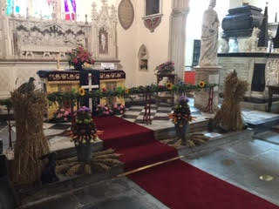
Tawstock is a large, rural parish, bordering south-west Barnstaple. It comprises several hamlets as well as the village of Tawstock itself. Total population is 700. The village boasts a church primary school and village hall, as well as Tawstock Court, a popular wedding venue. The parish is predominantly rural and agricultural festivals are important events in church.
Tawstock church is a popular attraction for visitors

The Church building is large and of historical interest, being for many centuries the family church for the owners of Tawstock Court. The Church benefits from a tea station and toilet and good disabled access. There is meeting space within the church as well as pewed seating. The magnificent organ has recently been restored. The churchyard is closed and maintained by the local authority. A public cemetery is located next to the church.
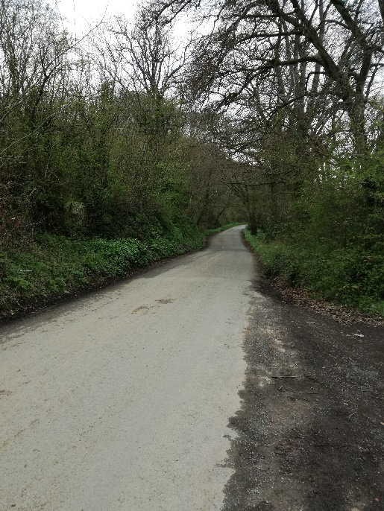
The church congregation is predominantly aged over 60. A new monthly family service is proving popular and is attracting baptism families as well as others from the surrounding area. Each year several couples attend in order to qualify for weddings and local families return to church for baptisms and special occasions. There is, therefore, a large fringe to work with. We have recently started a programme of special invitational services distributed through the year’
Services are varied in nature. Communion is celebrated monthly and on two other Sundays of the month congregation members lead the service.

The church pays its full quota each year and normally outgoings are met by giving.
Rush hour on the way to Tawstock

The leadership team

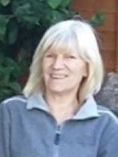
Carol: Reader and focal minister of Yarnscombe
Carol has an evident gift for getting alongside the frail and vulnerable. She has a gentle yet deep and strong faith which shows as she ministers to the people of Yarnscombe. Carol is happy to lead BCP services but also has a willingness to try new things.

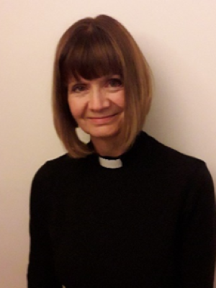
Caroline: PTO priest
Caroline is the newest member of our time and offers priestly support, helping enable communion to be celebrated at least monthly in each church as well as conducting baptisms and funerals. She offers a deep spirituality rooted in the liturgical tradition. Caroline has a real concern for the marginalised and those in need.

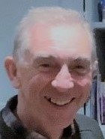
David: Reader
A dedicated and passionate disciple with a true and steadfast servant heart, David takes the Christian faith into the community through involvement in many community groups. He has a real strength in hosting and leading small groups. He lives with his wife Julia in a small intentional Christian community in High Bickington

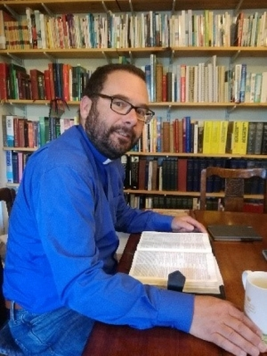
Gary: Team rector
Gary came to the team via a curacy in mid Wales and incumbencies in north Wales and Kent. He loves to dream dreams and have visions, is great encourager and enjoys preaching and teaching. He is married to Helen and has four children, two still living at home. A keen follower of Watford FC and Kent CCC he is used to the disappointments of life but retains a sense of hope and even optimism.

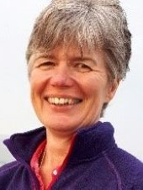
Jacque: Reader and focal minister for Roborough
Jacque is a true Devonian and has a wonderful knowledge and understanding of the rural community, its expectations and its pastoral needs.
Jacque works part time as PA to the archdeacon of Barnstaple and brings a vast wealth of understanding of the Diocese to the team.

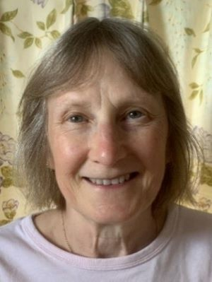
Jen: Church warden and focal minister of St Giles
Jen is a real encouraging and organiser, and under her guidance St Giles has grown from average attendance of 6 to 15, with most church members playing some part in the church’s ministry and outreach. She has a prayerful faith and a sees opportunities rather than problems.

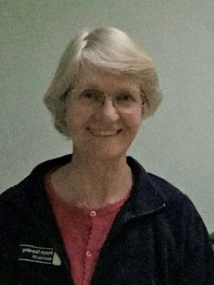
Julia: Parish Nurse-Deacon
Julia was ordained as a permanent deacon in September 2021 and combines this role with that of parish nurse. She has a heart for taking the love of Jesus to those outside the church. You will often find her weighing babies at toddler groups, visiting the sick and taking communion to the housebound.

Tim: Reader and focal minister for Newton Tracey with Alverdiscott, Horwood and Huntshaw.
Tim is a practical and capable member of our team, a great encourager and is always willing to speak out if he feels things are not right. He has organized and led Alpha courses, informal worship services, Messy church and taken a group to Spring Harvest.

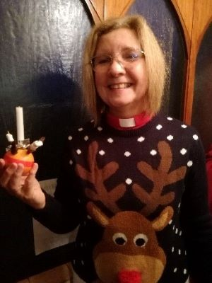
Tracey: Licensed Associate Priest (SSM)
Tracey serves as focal minister for High Bickington and Atherington and rural dean of Torrington. She has a real pastoral heart and loves working with children.
With her husband, Mick, she runs a bed and breakfast in High Bickington.
Tracey loves to sing and runs the choir in High Bickington.

The Surrounding area

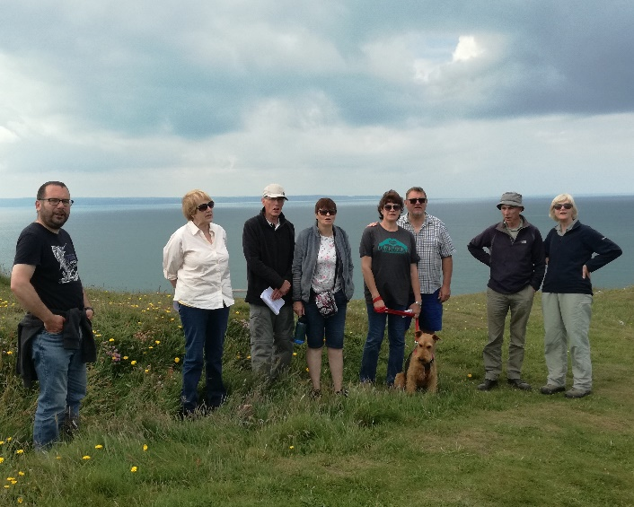
The Two Rivers Mission Community covers 55 square miles of beautiful Devon countryside between the principal town of Barnstaple and the market towns of Bideford and Torrington. The famous surfing beaches of Croyd, Woolacombe and Westward Ho! are just a short drive away and national parks of Dartmoor and Exmoor are withing easy reach.

The mission community itself is primarily agricultural and there are many local families who have earned their living from the land for generations. However, there are also many ‘incomers’, often from the South East of England, who have escaped the rat race for a slower pace of life. Incomers are welcomed and valued, especially when they get stuck into community life. Communities are close knit and work together for the common good. Most villages have a hall and programme of social activities. Church, alongside the local school, pub and shop (where they exist) are seen as part of the fabric of village life and are well supported. There are two church primary schools and two community primary schools in the Mission Community and all value their links with the Church. Secondary schools are located at Barnstaple, Torrington and Chulmleigh and most children access 6th form provision at Petroc college in Barnstaple or in Exeter.
Prayer walking at Baggy Point

Barnstaple provides leisure facilities including a Leisure Centre, a cinema and a theatre. In the centre of the town there is a Victorian Pannier Market. Adjacent to the Market is historic Butchers Row, a row of specialist food shops, some still open fronted. Barnstaple has a direct railway link to the cathedral city of Exeter, The Tarka Line, and a link road that takes you to the M5 motorway in under an hour.

Bideford, also known as the Little White Town, is associated with Charles Kingsley who wrote Westward Ho! and the Water Babies. The pedestrianised high street boasts a number of interesting independent shops, including a Christian bookshop. From the quay you can travel to the island of Lundy by boat.

Great Torrington has an historic centre and Pannier Market, a swimming pool, Dartington Crystal Factory and less than two miles away RHS Rosemoor. The Plough Arts Centre has a cinema, theatre and café.
Barnstaple, Bideford and Torrington are joined by the Tarka Trail; a disused railway line now made into a popular walking and cycling route, with a surprisingly steep uphill climb leading out of Torrington!

Mission Community statistics

Parish | Population | Participation figures  2021 | Baptisms  2021 | Weddings  2021 | Funerals  2021
Atherington | 320 | 5 | 0 | 1 | 3
Beaford | 393 | 7 | 1 | 2 | 3
High Bickington | 1600 | 18 | 1 | 0 | 5
Horwood | 125 | 7 | 2 | 2 | 2
Huntshaw | 180 | 3 | 0 | 0 | 1
Newton Tracey  With Alverdiscott | 500 | 15 | 0 | 0 | 0
Roborough | 250 | 9 | 0 | 0 | 0
St Giles | 568 | 9 | 3 | 0 | 0
Tawstock | 700 | 22 | 6 | 4 | 2
Yarnscombe | 330 | 10 | 1 | 1 | 0
Total | 4966 | 105 | 14 | 10 | 16

