St Peter’s Church, Tawstock

Annual Report and Financial statements
of the Parochial Church Council
for the year ended 31st December 2020

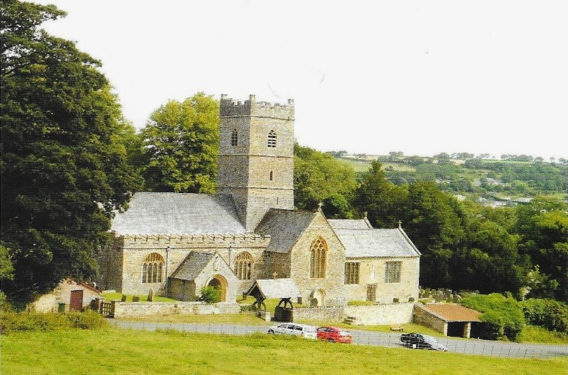

Rector: Reverend Gary Owen

Bankers: National Westminster Bank
41, High Street, Barnstaple, North Devon, EX31 1DA.

Independent examiner: .D. Cornwell
White Rose Cottage, High Bickington, Umberleigh, Devon, EX37 9EW.

Website: www.tworiversmissioncommunity.org

The Parochial Church Council is an Excepted Charity

The Parochial Church Council of St Peter’s Church, Tawstock
Annual Report
For the year ended 31st December 2020

Aim and Purposes
St Peter’s Parochial Church Council (PCC) has the responsibility of cooperating with the incumbent, the Rev Gary Owen, in promoting in the ecclesiastical parish, the whole mission of the Church, pastoral, evangelistic, social and ecumenical. The PCC is also specifically responsible for the care and maintenance of the church. North Devon District Council is responsible for the maintenance of the Church yard and the P.C.C. is grateful to the volunteers who also assist in maintaining the appearance of the graveyard.

Objectives and Activities
St Peter’s Church is part of the Two Rivers Mission Community, an area of 56 square miles between Barnstaple, Bideford, Torrington and Atherington. We aim to grow vibrant, faithful and sustainable Christian communities in each parish which meet weekly to worship, pray, grow as disciples of Jesus and reach out to our communities with the good news of Jesus.
We recognise that we exist to serve and bless the whole parish and to grow and make visible the kingdom of God. Our building and churchyard are valuable community resources and we value the support of parishioners in maintaining and utilising these for the benefit of the community.

Achievement and Performance
There are 22 on the electoral roll, who live in the parish. No new members were added nor removed. The average Sunday attendance was 24 before the Church had to close. As soon as legally allowed, the Church did open every Sunday for private prayer and, when permitted, reopened for Sunday worship.
Covid 19 had a significant effect on church life from February 2020. Whilst the church building was shut worship was maintained online via YouTube and Zoom.
Members of the Church and P.C.C. continue to support Holywell School although this has been limited this year due to the pandemic restrictions. The P.C.C. is delighted that it was still able to provide every pupil leaving the school in 2020 with a bible.
For information about achievements and performance as part of the Two Rivers Mission Community see appendix 1.

Deanery Synod
Due to the Covid-19 pandemic it was not possible for the deanery synod to meet. Deanery clergy met twice each month via Zoom to enable the sharing of information and mutual encouragement.

Church Fabric
The P.C.C. is delighted that the refurbishment and updating of our magnificent organ has been completed. The Covid 19 restrictions enabled the work to be completed in six weeks with no services being disrupted. The P.C.C. would like to thank all those who worked hard to raise the required capital and those who generously made donations. This generosity was essential in topping up the grant funding to ensure all the cost of the rebuild could be paid.

Financial Review
Despite the Church service collections being down by 48% due to the closure of the Church the Balance Sheet for the end of the year shows a surplus of £6,692. However, it should be noted that this is artificially elevated due to the transfer of funds from the CBF fund and the inclusion of grants to pay for the work on the organ. The P.C.C. has managed to maintain the common fund payment.
The PCC would like to thank everyone who contributed to church finances. Regular donations by the Parish Giving Scheme or standing order are particularly appreciated as they provide a regular income regardless of whether the building is open for worship and enable the PCC to manage a budget effectively.

Safeguarding
The PCC has complied with the duty under section 5 of the Safeguarding and Clergy Discipline Measure 2016 (duty to have regard to the House of Bishops’ guidance on safeguarding children and vulnerable adults).
The safeguarding officer is Mr Derek Birch.

Structure, Governance and Management
The method of appointment of PCC members is set out in the Church Representation Rules. The council comprises the incumbent, licensed clergy, churchwardens, readers appointed by the Annual Parochial Church Meeting, those elected to the deanery synod and other members elected at the Annual Parochial Church Meeting, by those on the electoral roll.
The PCC members are responsible for making decisions on all matters of general concern and importance to the parish and for all financial matters. Two representatives of the PCC are elected by the PCC to serve on the Mission Community Council and are delegated to take decisions on behalf of the PCC in regard to Mission Community matters.

Administrative information
The church is situated in Tawstock, EX31 3HZ. The parish is in the deanery of Torrington, archdeaconry of Barnstaple and Diocese of Exeter. The correspondence address is The Rectory, High Bickington, Umberleigh, EX37 9AY.
The PCC is a body corporate (PCC Powers Measure 1956 and the Church Representation Rules 2020) and a charity excepted from registration with the Charity Commission.
PCC members who have served since 1st January 2020 until the date this report was approved were:
Ex officio
The incumbent | Rev Gary Owen | Chair
Licensed clergy | Rev Tracey Doyle
Reader(s)
Deanery synod rep
Church wardens | David Smallridge, John Andrew (until end of June 2020) | Vice chair

Elected
 | Mr & Mrs Smallridge, Mr & Mrs Pratt, Mrs Nickols, Mr Andrew, Mr Elliott, Mr Kempton, Mr Tucker, Mrs Watson Davis
 | Malcolm Elliott | Secretary
 | John Andrew | Treasurer

Approved by the PCC on date and signed on its behalf by:

………………………………….. …………………………………..
Rev Gary Owen [Insert name, ]Vice chair

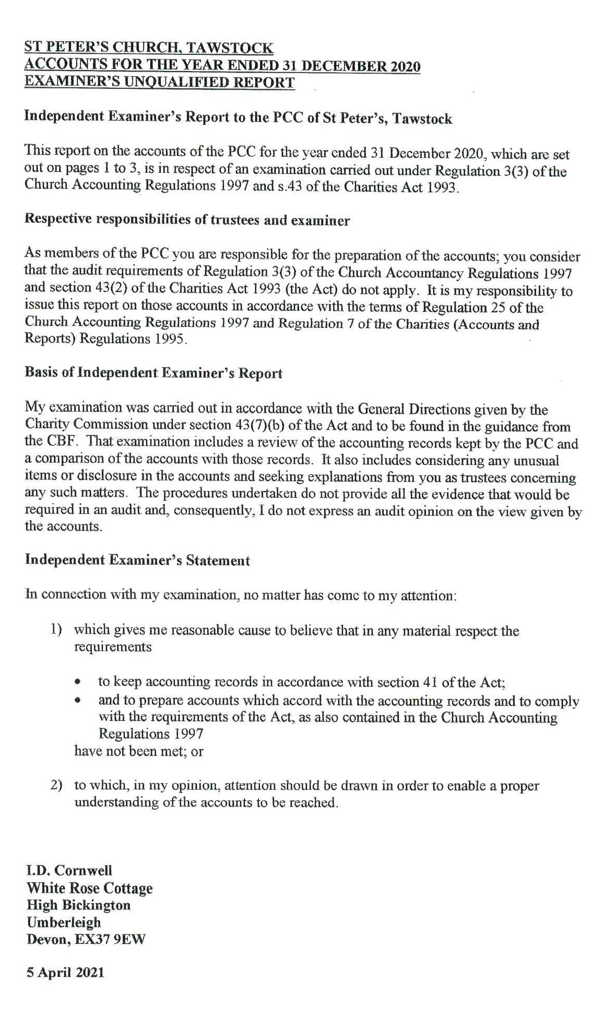
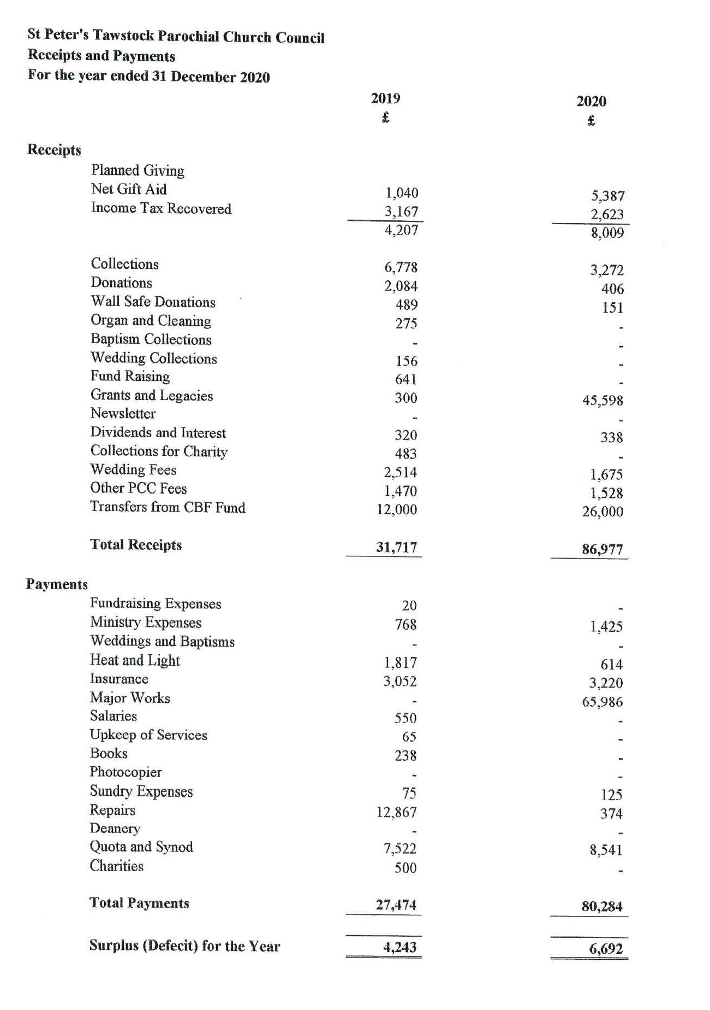
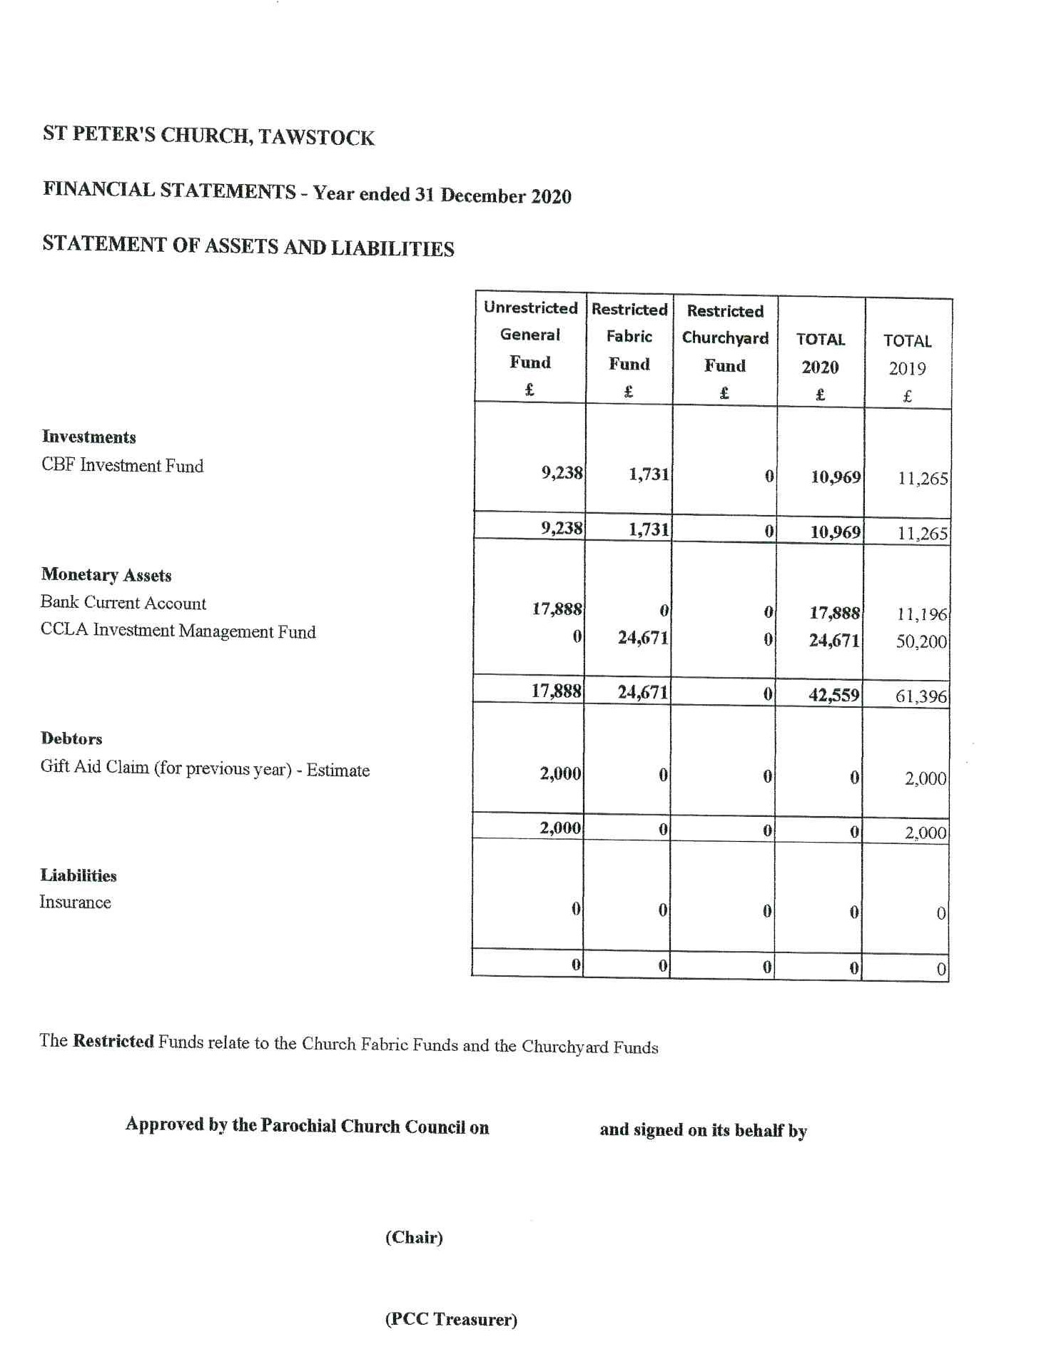

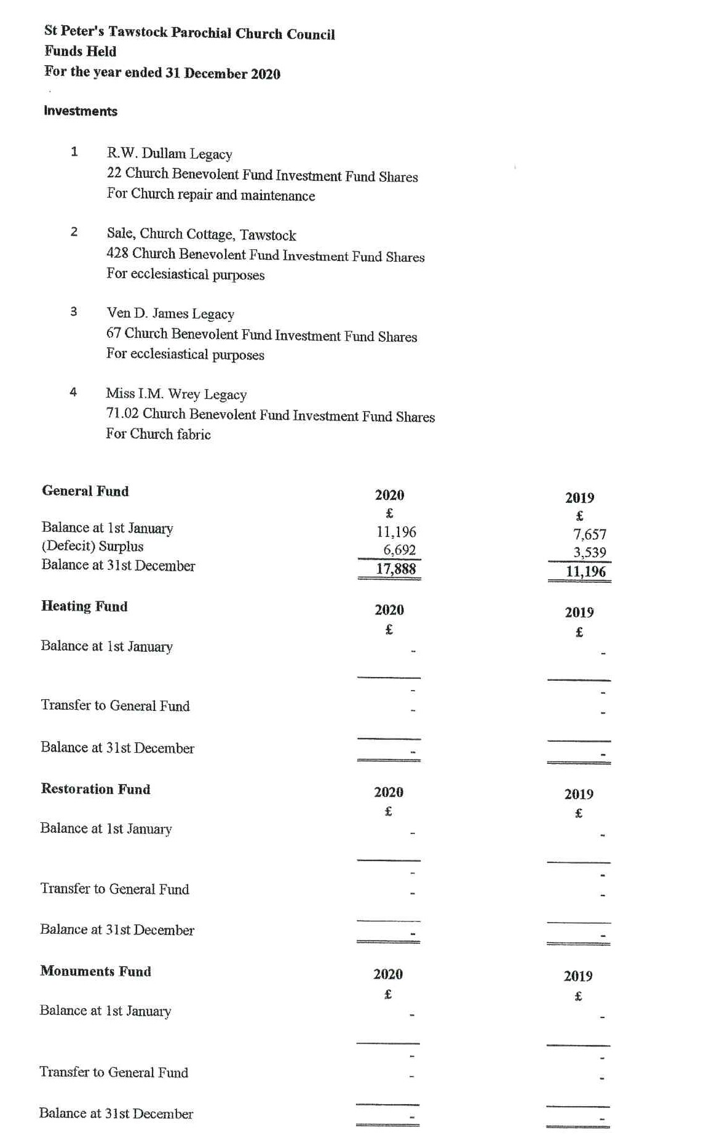
Appendix 1
Two Rivers Mission Community Annual Report 2020

The year began like most others, but by February news of a new virus was breaking and by March we were in lockdown. In addition to contact through personal relationships, the new mission community database allowed us to keep in touch with over 160 church members. We switched services to YouTube, and increasingly Zoom, and sent prayers and liturgies by post to those without internet access. As soon as permissible, church buildings were opened one day per week for prayer and when permitted nine of the eleven buildings were reopened for Sunday worship. This continued throughout the year, with the exception of a second national lockdown in November. Tribute needs to be paid to the ministry team, wardens and others who worked hard to make our buildings Covid secure and make it possible for worship to continue.

Church members did their best to love and practically care for their communities. Food boxes, prayer request boxes and books appeared in various church porches. Help was offered with shopping. Doorstep singing was organised in Horwood. Neighbours looked out for each other. We were able to offer covid compliant support through our parish nurse. A listening service was set up by church members in Horwood and Newton Tracey.

Government restrictions on church activities meant that few baptisms took place during the year; just two and most weddings were postponed or cancelled with just four taking place. Funerals remained possible throughout the year, although for a period only in churchyards and always with limited numbers. We conducted 20 funerals in church and 7 at the Crematorium.

Sadly, many of our church activities had to be suspended. Both youth groups ceased to meet. Coffee mornings were suspended, although we did offer a Zoom coffee morning in April and May. Homegroups met for periods either online or in person. Zoom did not prove to everyone’s liking and others were unable to access the technology but for those able to join in these proved valuable means of support and spiritual growth. Our usual support of the four schools within our mission community switched online with Rev Tracey and Rev Gary providing weekly recorded collective worship. Rev Tracey organised a Christingle bag for every child in the four schools at Christmas.

Christmas provided some limited relief, with outdoor services and carol singing being permitted. Several churches attracted good numbers and won goodwill holding crib building, carol singing or Christmas services. Loved ones were remembered by hanging named stars on Christmas trees.

Despite the difficulties of the circumstances we did our best to progress the Mission Community Vision. We managed to hold weekly services in seven of our eleven churches. In several of these churches church members stepped up to the plate, leading services with support in the form of service sheets or sermons provided by the ministry team. Our aim is to meet at the same time in the same place every week, both for the building up of the church congregation but importantly so that members of the community can be confident that when they want to come to church there will be a service in their village for them to attend. We aim to use Sunday services to worship, pray, grow as followers of Jesus and reach out with the good news of Jesus. Some creative ways of reaching out were the delivering of posies on mothering Sunday and harvest, open air services at war memorials, and carol singing in public places.

During the year Alverdiscott became a chapel of ease of Newton Tracey, it was not possible to reopen Huntshaw church and the AGM decided to become a festival church. A long discernment process resulted in Horwood and Newton Tracey deciding to each meet twice per month in each building and not weekly. Despite three attempts we failed to appoint a half-time team vicar, with a lack of unity in the mission community being given as one of the reasons why one candidate didn’t wish to accept the post. Once meeting in person becomes possible again, the mission community will need to decide how to proceed from here – given the situation we currently find ourselves in and not the one detailed in the parish profile two years ago.

The ministry team continues to meet weekly via Zoom for prayer, planning and mutual support. The Mission Community Council meets quarterly to progress the ministry and mission of the Mission Community. These meetings were held via Zoom in 2020. Most PCCs met infrequently, if at all, during the year, but the churches seemed to manage fine with church members pulling together on a more informal basis. The Mission Community expense account ended the year in surplus (in the region of £3,000) largely due to the community not enjoying the services of a second stipendiary cleric and reduced administration and travel costs due to Covid. Eight of the ten PCCs maintained full common fund payments with the other two aiming to make up their shortfalls in 2021. I commend the churches for maintaining their payments – both because it is important to pay for ministry received and because God has promised to bless those who are generous to him. The hope is that in 2021 we will be able to meet once more in person and having agreed a common vision, will be able to set up a Joint Council which will make administration less onerous.

I would like to pay tribute and offer thanks to everyone who has worked so hard to keep the Mission Community operating during this most difficult of years. The ministry team and those taking services have adapted admirably, and shown great patience and forbearance, with quickly changing circumstances. Wardens and PCCs have worked carefully and patiently to keep buildings Covid secure and open and to maintain contact with church members and vulnerable members of the community. Church members have prayed, shown love in practical ways and maintained a sense of humour and good will.

It is impossible to predict what might happen in 2021. Let’s pray that Covid is brought under control, that some normality of life resumes and that our local economy recovers. Let’s pray for those who have lost loved ones, suffered illness or lost livelihoods. Let’s be ready to accompany those who will emerge from Covid scarred or in need of support.

And let’s resolve to do what we can to keep our churches alive and active as signs of God’s presence amongst our villages; as beacons of light and life. Let’s maintain our commitment to worship, pray, grow as disciples of Jesus and reach out to our communities with the Gospel. Let’s be people who know that Jesus is Lord, that one day all will be well and that in life’s difficulties we are more than conquerors through him who loves us.

